**HO CHI MINH CITY UNIVERSITY OF TECHNOLOGY**

**DEPARTMENT OF TELECOMMUNICATIONS ENGINEERING**

**--------------------------**



**DIGITAL COMMUNICATIONS**

**GPS DETECTER PROJECT**

**Students : Vương Minh Phú-1551112**

**Lê Hoàng Giang-1551032**

*HCM City 2019*

**Contents**

1. Abstract 3
2. Install frameworks 3

1. Visual Studio Code Insider 4

2. Create Google map API account 4

3. Create Firebase account 4

4. Internet information services manager 4

5. Android Studio 4

1. Local website 3
2. GPS detector android app 4
3. Applications 4
4. Experiment 14
5. Results 16
6. Conclusion 20
7. Reference 20

**I/ Abstract:**

In this report we describe how to build a system to locate a phone run on android operating system. Our system include an android app and a website include Google API. First, by using the basic library in and the GPS chip in android device, we can take longitude and latitude from where it stand, then put its location into JSON Object and send it to our local web. In our server, Google map API requires longitude and latitude to return device’s location.

**II/ Install Framework:**

**1/ Visual studio code insider:**

**1.1/ What is visual studio code insider?**

Visual Studio Code is a lightweight but powerful source code editor which runs on your desktop and is available for Windows, macOS and Linux. It comes with built-in support for JavaScript, TypeScript and Node.js and has a rich ecosystem of extensions for other languages (such as C++, C#, Java, Python, PHP, Go) and runtimes (such as .NET and Unity). It is a free framework provided by Microsoft.

1.2/ How to download and install Visual studio code insiders?

First, go to this link:

<https://code.visualstudio.com/insiders/>

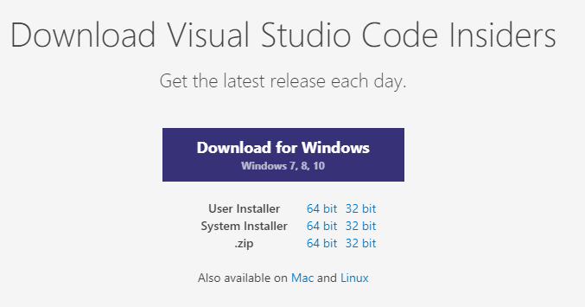

Choose the biggest purple rectangle which has text “Download for Windows” for download the “.exe” file.

After finish, run the download file and install normally.

**2/Create Google map API account:**

**2.1/ What is Google map API? Why Google map API? What for?**

_ Google maps is an free application provided by Google company through the URL “map.google.com” or mobile app. People can easily take their location and find the best road in every hours.

_ Google maps API is an application programming interface with Google map and approach the giant data of Google in order to create a third app for economic or research.

_ Google maps have data of more than 200 countries and cover 99% earth area. Over 25 millions location’s updates from collaborators and Google Local Guide teams around the world everyday. About one billion users each month.

_ Google API support for web, app and webservice developer.

**2.2/ How to create Google Maps API Keys:**

_ First, go to the URL: <https://developers.google.com/maps/documentation/>

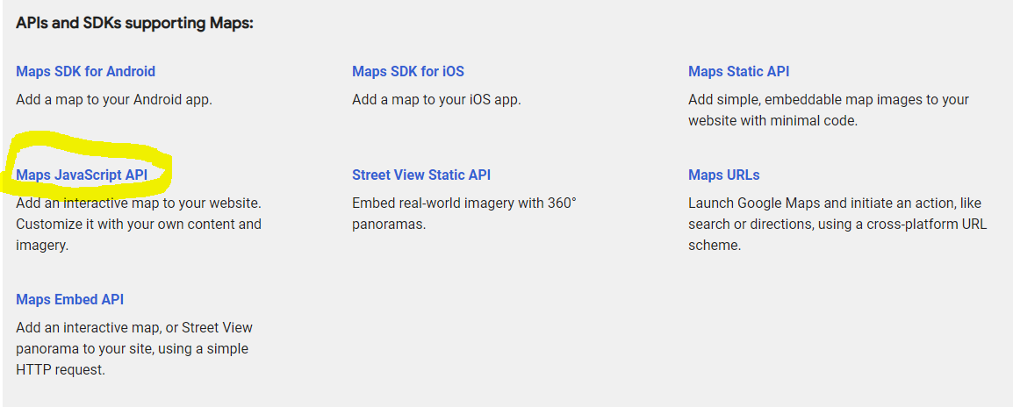

_ Choose Maps JavaScript API

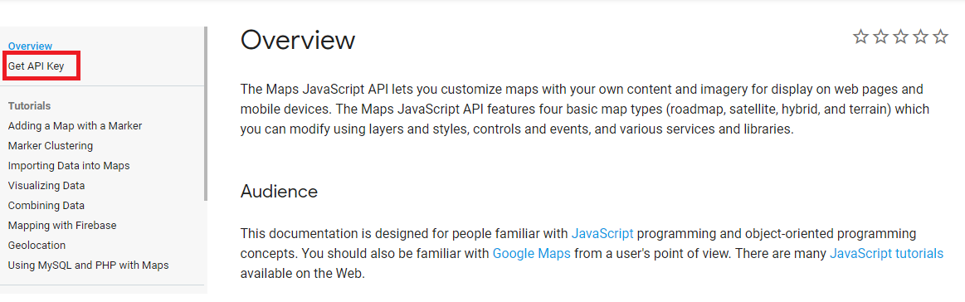

_ Choose Get API Key.

_ Then just follow the guide in order get API Key.

**3/ Create Firebase Accounts:**

**3.1/ What is firebase? Why we use Firebase?**

_ Firebase is a Backend-as-a-Service — BaaS — that started as a YC11 startup and grew up into a next-generation app-development platform on Google Cloud Platform.

_ Firebase frees developers to focus crafting fantastic user experiences. You don’t need to manage servers. You don’t need to write APIs. Firebase is your server, your API and your datastore, all written so generically that you can modify it to suit most needs. Yeah, you’ll occasionally need to use other bits of the Google Cloud for your advanced applications. Firebase can’t be everything to everybody. But it gets pretty close.

_ It’s realtime database.

**3.2/ How to get firebase key:**

_ First, log in to Firebase home website by link: <https://console.firebase.google.com/u/0/>

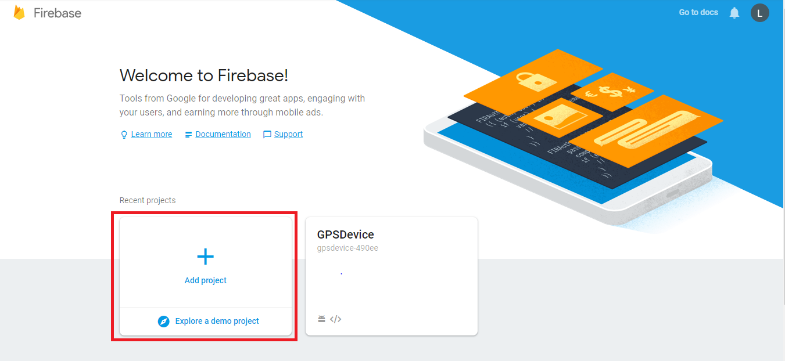

_ Then choose Add Project

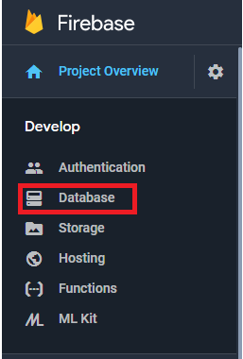

_ Choose Database

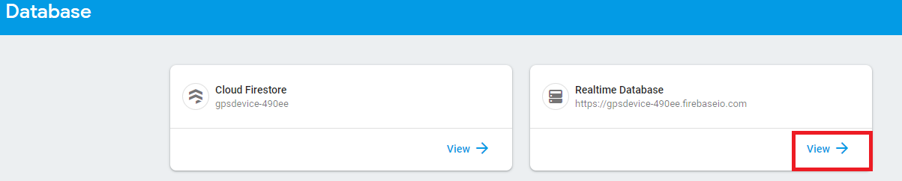

_ Choose Realtime Database

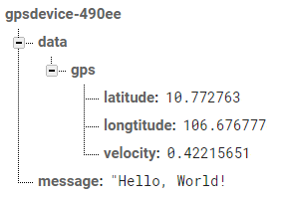

_ Create your variable.

_ Then we can push or pull data from Firebase in realtime.

**4/ Internet information service manager (IIS)**

**4.1/ What is it?**

_ IIS (which stands for Internet Information Services or Internet Information Server) also known as Windows web server is available on most versions of Microsoft Windows operating systems and takes second place in overall usage behind Apache HTTP Server on the internet. It will host websites, web applications and services needed by users or developers. Many versions have shipped as far back as IIS 1 on Windows 3 and with nearly every new Windows OS a new IIS version follows.

**4.2/ How to install and use IIS?**

_ Keeping with Microsoft modular design of, uhm, everything these days, IIS in Windows is still an optional “Windows Feature”. To install it, press the Windows + R key combination to bring up a run box, then type appwiz.cpl and press enter.

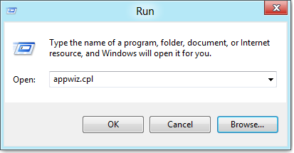

_ This will open the Program and Features part of Control Panel, on the left hand side click on the “Turn Windows features on or off” link.

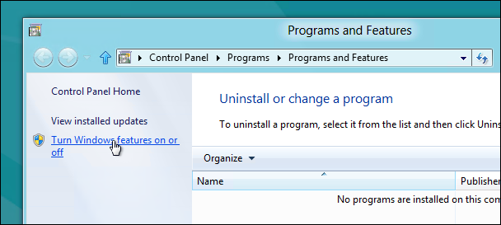

_ Now click on the Internet Information Services check box.

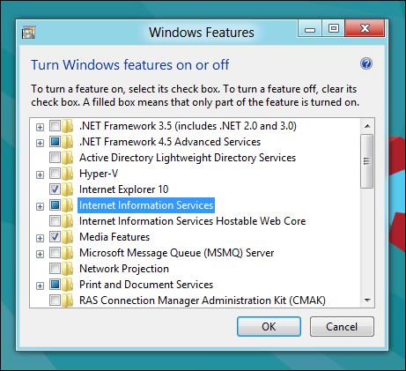

_ If you’re a developer you are going to want to expand it and explore the sub-components as well. By default it installs all the stuff needed to host a website, and you are probably going to need some of the more developer centric components as well.

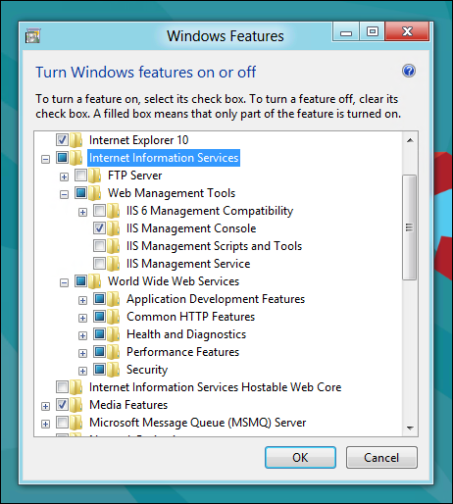

_ After clicking OK, this dialog will appear on your screen for a while.

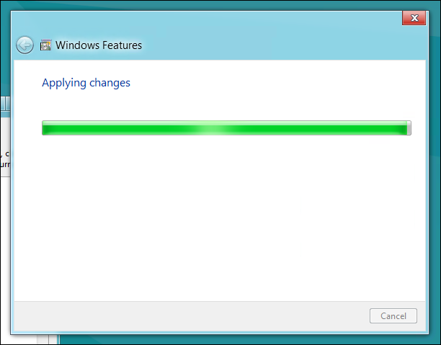

_ Then find IIS in start menu, you will see

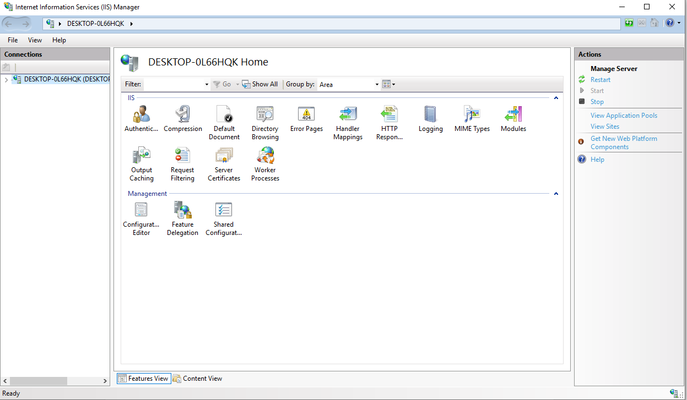

**5/ Android Studio**

**5.1/ What is Android Studio**

_ Android Studio is the official integrated development environment (IDE) for Google's Android operating system, built on JetBrains' IntelliJ IDEA software and designed specifically for Android development. It is available for download on Windows, macOS and Linux based operating systems. It is a replacement for the Eclipse Android Development Tools (ADT) as the primary IDE for native Android application development.

**5.2/ Install Android Studio**

_ Go to Android Studio home page: <https://developer.android.com/studio>

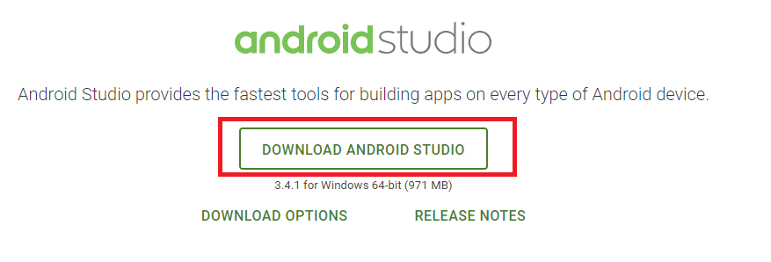

Choose Download android studio then follow the guild to get